**Laporan Praktikum DML**

Nama : Febriyani Nurhida

NIM :312210222

Kelas : TI.22.A2

menambah data :

``INSERT INTO <table> (field1, ..., fieldn) VALUE (value1, ..., valuen)``

contoh :

``INSERT INTO biodata (nim, nama, alamat) VALUE ('1234','Rio','Bekasi');``

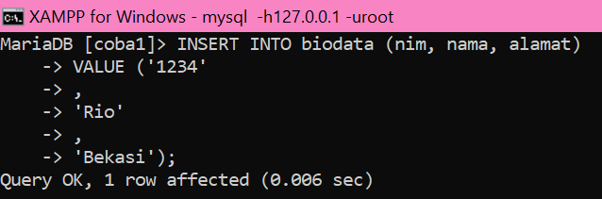

2. menampilkan data :

``SELECT * FROM <table>``

``SELECT [field1, ..., fieldn] FROM <table>``

contoh :

``select * from biodata;``

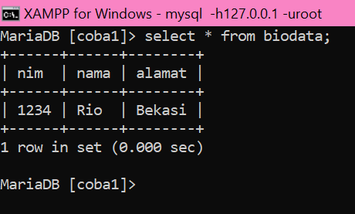

atau untuk memfilter data gunakan perintah :

``SELECT * FROM WHERE <kondisi>``

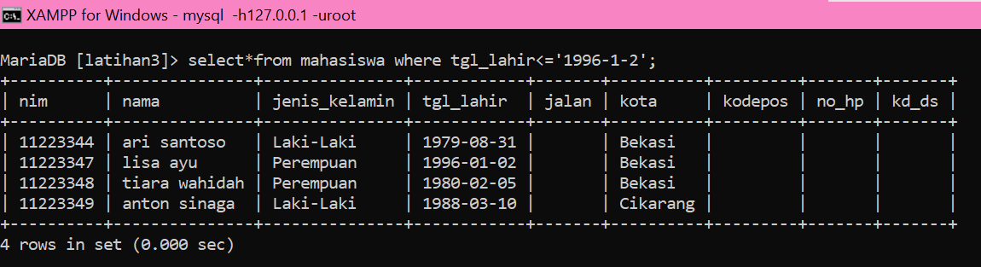

3. mengubah data :

``UPDATE <table> SET field1=val1, ..., fieldn=valn WHERE <kondisi>``

contoh :

``UPDATE biodata SET nama='Rio', alamat='Bekasi' where nim='123344';``

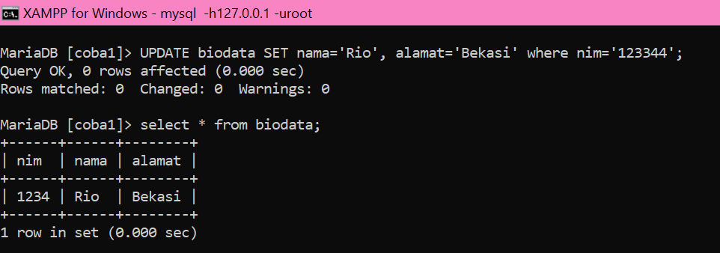

4. Menghapus data :

``DELETE FROM <table> WHERE <kondisi>``

contoh :

``DELETE FROM biodata WHERE nim=‘12334’``

